CHAPTER 3
LARGE LANGUAGE MODELS

Chapter Map
Section | Main teaching idea
3.1 History | Evolution from rule-based systems to modern LLMs
3.2 Python use | LLM calls, providers, multimodal and local models
3.3 Parameters | Temperature, top-p, top-k
3.4 Model selection | Performance, cutoff, hosting, price, context, latency
3.6 Prompt templates | Reusable prompts and variables
3.7 Chains | Sequential, parallel, router, memory
3.8 Safety & security | Input threats and harmful output
3.9 Improvements | Prompting → RAG → retraining/fine-tuning
3.10 Trends | Reasoning, SLMs, test-time compute
3.11 Summary | Integration and link to later chapters

Section 3.1 — Brief History of Language Models
Recommended time: 1 lecture
- ELIZA: an early rule-based chatbot using patterns and generic responses.
- N-gram models: statistical models that use nearby words and local context.
- RNN/CNN and later LSTM/GRU: improved handling of sequences and relationships.
- Transformers: a major step toward modern large language models.
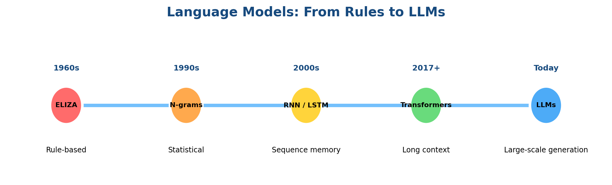
Figure 1. Teaching diagram for the evolution of language models.
What to cover
Students should understand the sequence of development and why each stage was an improvement.

Section 3.2 — Simple Use of LLMs via Python
Recommended time: 2 lectures
- Basic flow: choose a model → send messages → receive the model response.
- OpenAI and Groq are used as examples of different providers. (detailed explanation will be ignored)
- API keys are credentials and should be handled safely.
- Multimodal models can work with more than text, including images, audio and video.
- Local LLMs can be useful when privacy, offline use or internal hosting matters.

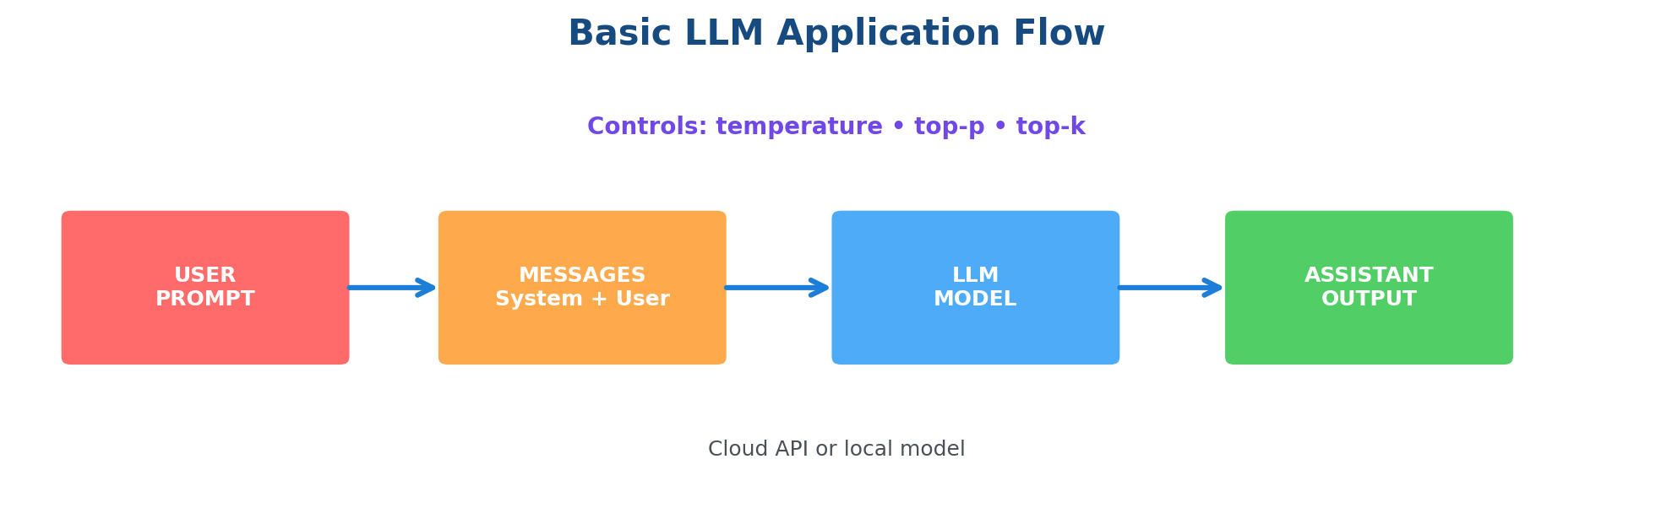
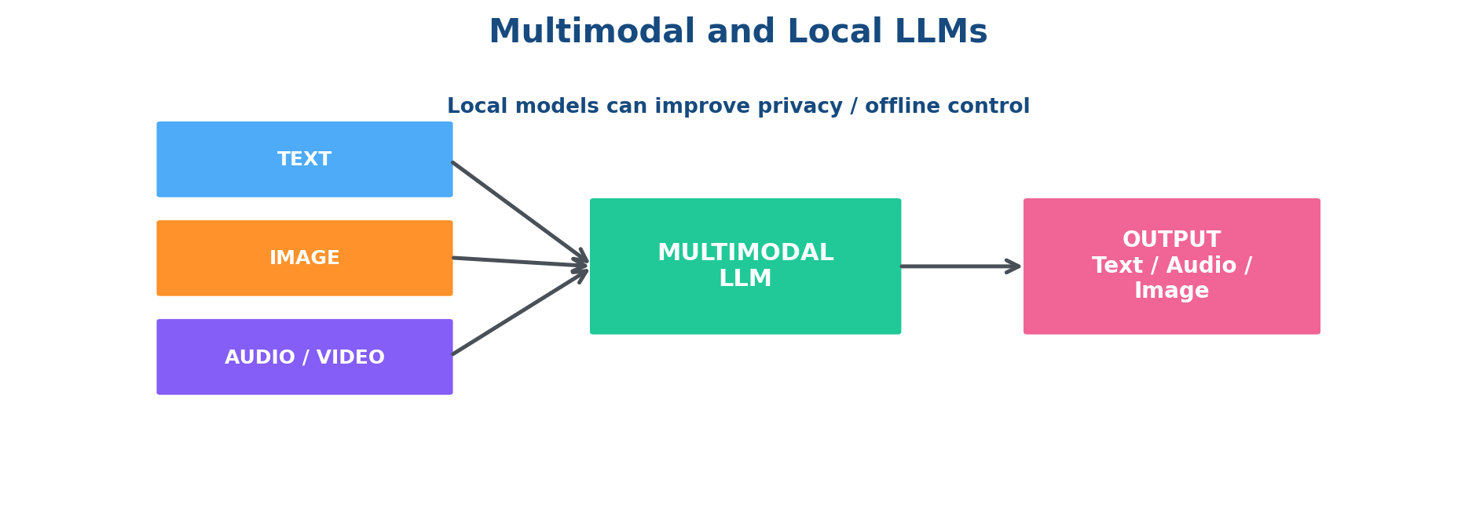

Section 3.3 — Model Parameters
Recommended time: 1 lecture
- Temperature controls how random or predictable the output is.
- Top-p keeps a dynamic group of likely next tokens based on cumulative probability.
- Top-k keeps a fixed number of likely next-token choices.
- Use creative writing versus code/customer support to show why settings differ.
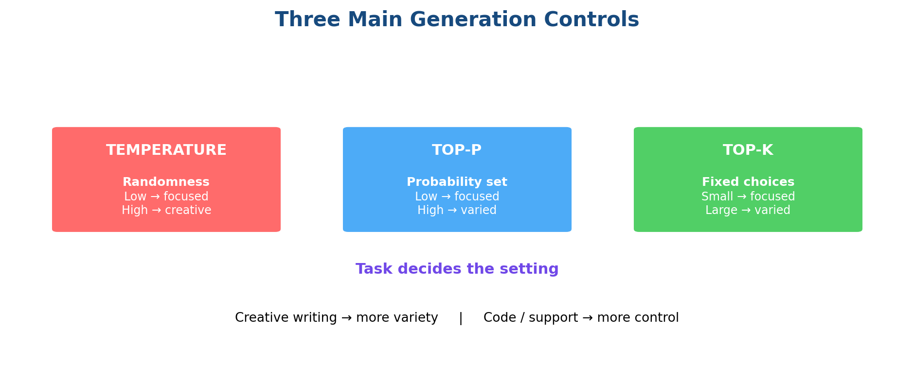

Section 3.4 — Model Selection
Recommended time: 1 lecture
- Performance — how well the model completes the task.
- Knowledge cutoff — how recent its built-in knowledge is.
- Hosting — cloud versus on-premise/local.
- Model type — proprietary, open-weight or open-source as described in the chapter.
- Price — service cost and/or local hardware cost.
- Context window — how much input the model can process.
- Latency — how quickly the system responds.
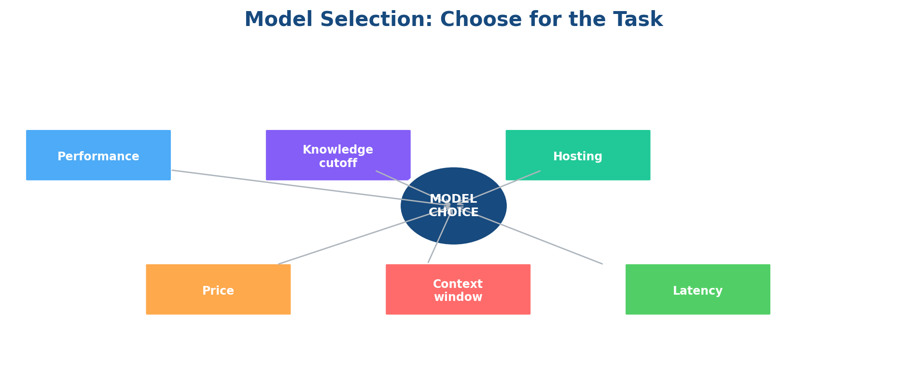

Teaching message
There is no single 'best' LLM. The right model depends on the task, privacy needs, budget, input size and response-time requirements.

Sections 3.5–3.6 — Messages and Prompt Templates
Recommended time: 1 lecture
- User message = the human request.
- System message = role, behavior, boundaries and objectives.
- Assistant message = the model response.
- Prompt templates create a reusable structure and can contain variables such as {input} or {target_language}.
- ChatPromptTemplate is introduced as a convenient way to structure messages.
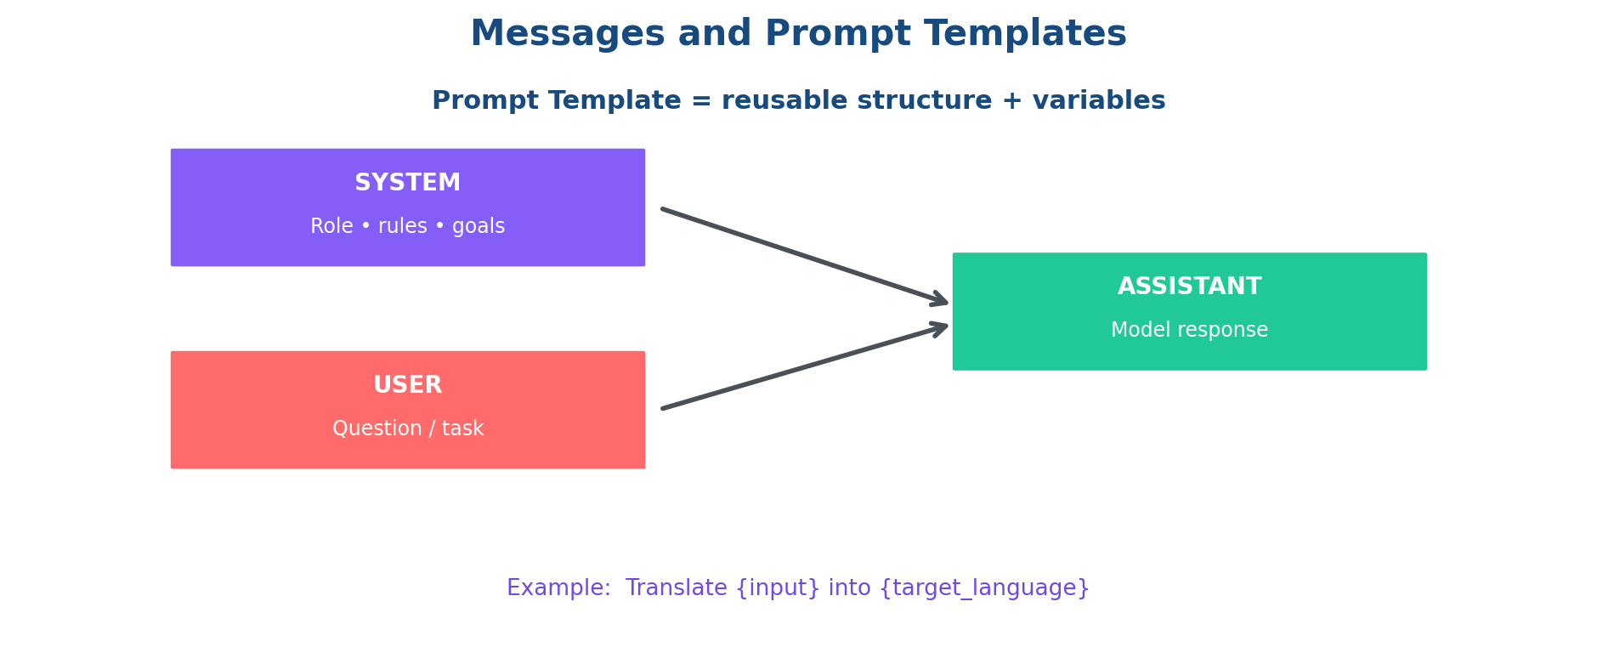

Suggested example
Use: 'Translate {input} into {target_language}' to show how one template can handle many inputs.

Keep brief / ignore
LangChain Hub should be mentioned only briefly. Metadata fields need only a short awareness of token usage.

Section 3.7 — Chains
Recommended time: 2 lectures
- Sequential chain: one step feeds the next step.
- Parallel chain: independent chains can run at the same time and their outputs can be combined.
- Router chain: a query is directed to the most suitable chain.
- Memory: previous interaction history can be retained and used by the system.
- Conceptual pipe: prompt → model → parser.
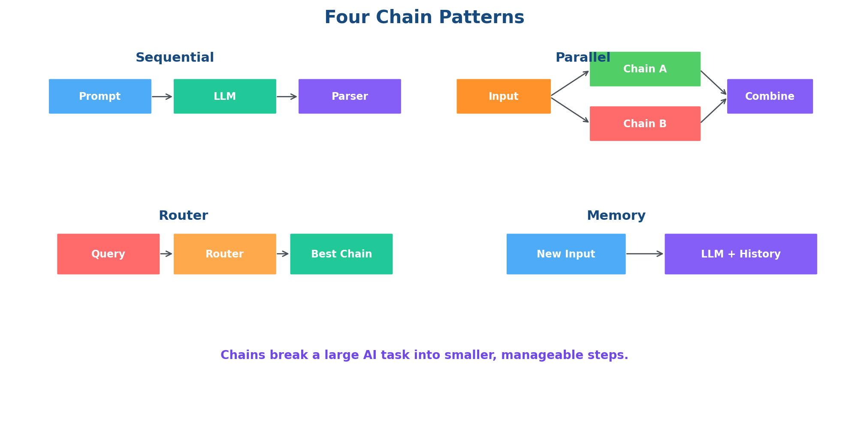

Section 3.8 — Safety and Security
Recommended time: 1 lecture
- Security protects the system from malicious or unsafe input.
- Safety protects users and systems from harmful model output.
- Security risks include adversarial attacks, prompt injection, data poisoning and robustness issues.
- Safety risks include bias, hallucination, PII leakage, ethics, misinformation, off-topic responses and reputational damage.

Section 3.9 — Model Improvements
Recommended time: 0.5 lecture
- Start with direct prompting.
- If the response is weak, improve the prompt.
- If the model needs current, private or external knowledge, add relevant information at runtime using RAG.
- If the knowledge really needs to be embedded into model weights, retraining/fine-tuning may be considered.
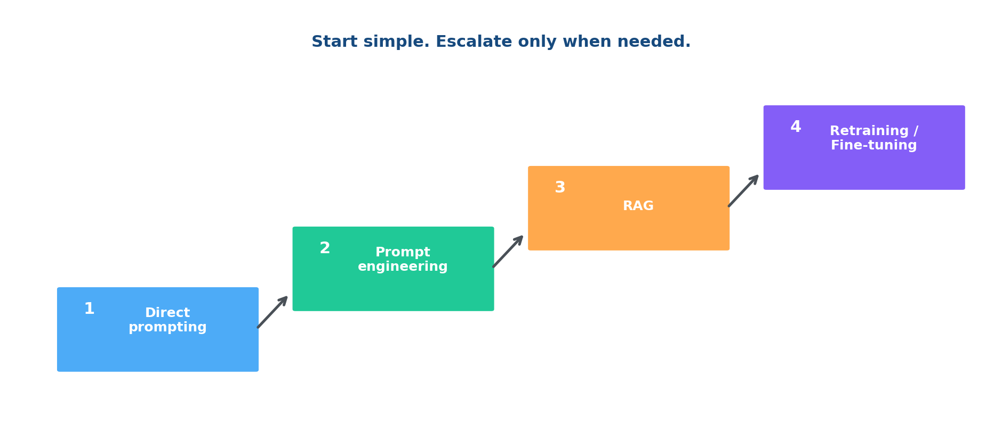

Section 3.10 — New Trends
Recommended time: 0.5 lecture
- Reasoning models: designed to spend more effort on complex reasoning tasks.
- Small language models: reduce model size and resource requirements and can support local/edge use.
- Test-time compute: adds computation/search during inference to improve reasoning.
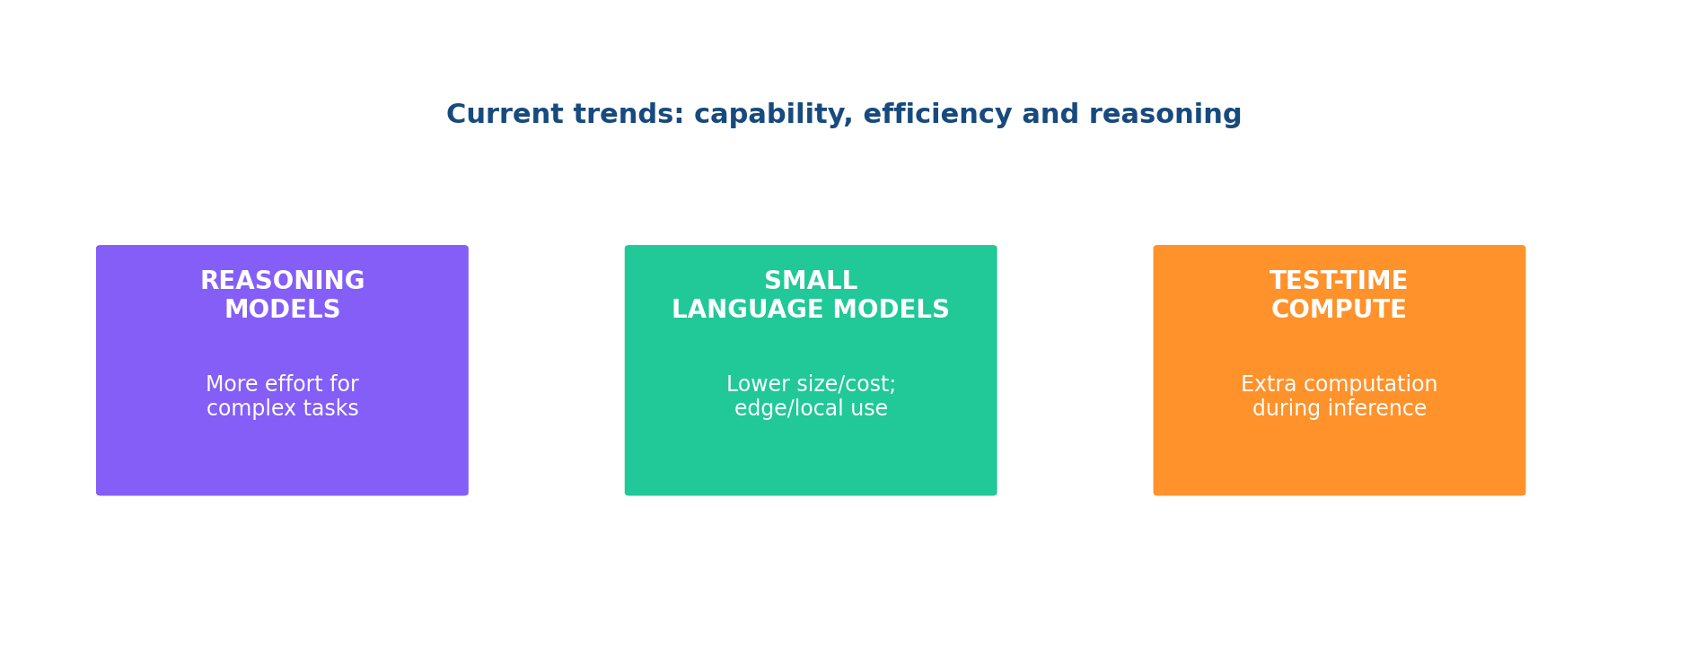

Section 3.11 — Summary and Integration
Recommended time: 0.5 lecture
- Review the flow: history → Python use → parameters → model selection → messages → prompt templates → chains → safety → improvement → trends.
- Connect Chapter 3 to Chapter 4 (Prompt Engineering), Chapter 5 (Vector Databases), Chapter 6 (RAG), and later deployment/application topics.
- Use one integrated LLM application example to connect messages, parameters, prompt templates, chains and safety.

